Petnames: A humane approach to secure, decentralized naming

Christine Lemmer-Webber, Mark S. Miller, Zachary Larson, Kate Sills, Eli Yaacoby

Table of Contents
1. The what and why of petname systems
2. Implementing petnames
2.1. Smartphone contact list integration
2.2. Web browser integration
3. Conclusion
"If we ever show a DID to a user we have failed."
Names must be human-readable in order to be widely used. Unfortunately, while DIDs and Tor .onion addresses are decentralized and globally unique, they are not human readable. How can we build user interfaces that real users might actually use? In this paper we provide an overview of petname systems, a way of mapping human readable names to cryptographically secure names, and describe changes to two user interface designs that we believe that are compatible with intuitive user expectations. We first discuss the smartphone contact list as already approximating petnames to some degree and discuss how to augment it with secure introduction. We then walk through several changes to browsers (which may be provided natively or as an extension) which add the functionality of a petname system. By utilizing petname systems we are able to collectively support individual naming definitions, community curated directories of names, as well as existing naming authorities such as certificate authorities and the domain name system, government agencies such as trademark offices, and decentralized systems such as Namecoin.

The what and why of petname systems
"What's the use of their having names," the Gnat said, "if they won't answer to them?"
"No use to them," said Alice; "but it's useful to the people that name them, I suppose. If not, why do things have names at all?"
– Through the Looking-Glass, and What Alice Found There
Zooko's Triangle tells us that names can have two out of three properties: decentralized, globally unique, human meaningful. DIDs and tor .onion addresses are decentralized and globally unique; they are intentionally not built to be human readable, and yet are meant to be used by humans. Consider the following example DID:
did:example:fbc0f54d1a084b469490ff78d55632ea
Identifiers like this look like gibberish to you and me, so how can we use them?
Petnames offer a way forward by mapping local names to global identifiers and vice versa. By adding a petname system as an additional layer to a globally unique and decentralized system, we are able to achieve all three properties.
A "petname system" is a database and a set of interfaces which use that database to bidirectionally map human readable names to cryptographically secure names. The three types of names in a petname system are:
- petnames: These are set locally by a user to map local meaning to an external identifier. For example, "Mom", "Uncle Bob", and "Pawnee Library".
- edge names: Every entity in a petname system may act as its own namespace, providing "paths" to names to other entities in the system as a graph, and these provided names are called "edge names". For example, "example.org" is an edge name in "dns ⇒ example.org", and "Sarah Smith" is an edge name in "Uncle Bob ⇒ Sarah Smith". We don't have to get rid of popular naming systems like DNS, but can absorb them in such a way that they are on equal footing with any other entity.
- proposed names: These are names which are introduced within a local context. For example, email permits users to specify a name on its addressing along with the email address. If you get an email that is cc'ed to `Ben Bitdiddle <ben@example.org>`, "Ben Bitdiddle" would be the proposed name.
  - self-proposed names In some applications, such as in social network software, it is possible to retrieve an entity's profile to see how that entity would like itself to be referred to. We call this a self-proposed name.

Implementing petnames

Smartphone contact list integration
One system that is already very similar to a petnames system is a smartphone's contact list application. Contact list applications use phone numbers as a global namespace without making phone numbers the primary user experience. Human meaningful names are mapped to phone numbers with no pretense that the names have global experience; the names are chosen by each human operator according to what is useful to them. The UI uses this mapping both to search and select entities from a contact list to display a name in an incoming call, or to review call history. The rendering it done in terms of a live mapping; should an entity's petname be updated, that petname will be retroactively updated on the call history.
So a smartphone contact list brings us reasonably far, but not quite far enough. Let's consider a scenario in which we can explore the rest of the pieces to complete this puzzle.
Alyssa receives a phone call from 1-324-555-8953. However, when she checks her phone to answer it, she does not see the phone number itself, she sees "Mom", which is the petname she has bound locally to the phone number.

Alyssa answers the call and her mother, Dr. Nym, mentions that she's giving a special lecture on mathematics that she would like help organizing, and wonders if any of Alyssa's friends may be interested in attending or assisting. Alyssa offers to help and suggests that her long-time friend Ben Bitdiddle may be interested in both attending and helping.
Dr. Nym says goodbye to her daughter and hangs up the phone. She searches for "Ben" in her contact list:
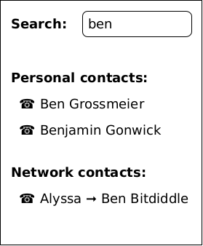
The "personal contacts" section shows petnames of people she knows, and "Ben Grossmeier" is a research colleague of Dr. Nym's. The "network contacts" shows edge names published by entities Dr. Nym has stored locally as, petnames. Dr. Nym has stored her daughter as "Alyssa", and so when she sees "Alyssa ⇒ Ben Bitdiddle" ("Ben Bitdiddle" being the edge name supplied by Alyssa) she is confident this must be her daughter's friend. She clicks this entry and dials Ben.
Ben hears an incoming call and sees that the caller is labeled "Alyssa ⇒ Jane Nym" and in smaller text "Faculty ⇒ Dr. Nym".
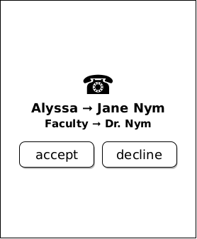
While Ben did not have Dr. Nym saved with a local petname, he has both Alyssa and the university's Faculty directory saved as local petnames, and from the both of those remembers that Alyssa's mother is named Jane Nym and that she is a professor on campus. Ben accepts the call and enthusiastically agrees to help Dr. Nym set up the event. Ben offers to coordinate food for the event, and Dr. Nym enthusiastically states that while she will place an order for pizza, she would not have time to pick it up beforehand, and so help there would be greatly appreciated.
Ben decides that since he is helping out that he should store Dr. Nym's contact information permanently in his address book. Ben checks the call history and sees that the first item says a call from "Alyssa ⇒ Jane Nym". He selects "Save Contact" from a menu.
On the edit screen that appears, a "local name" widget is immediately selected with a suggested entry of "Jane Nym" highlighted in such a way that if Ben were to begin typing he could override this text.
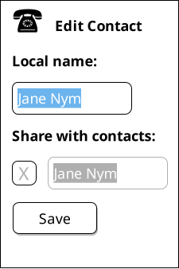
Ben decides this name is good enough; since he knows Alyssa's mother on a personal basis through Alyssa, he is comfortable thinking about her as Jane Nym. Ben decides that he would also like to share this contact as an edge name with the rest of his contacts, and so presses the "share with contacts" button. Once again Ben is presented with an editable field with the name "Jane Nym" preselected, but Ben decides to edit this edge name to be called "Dr. Nym".
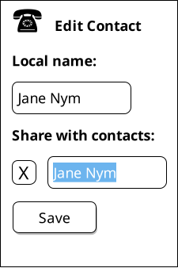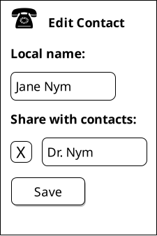
While Ben knows Dr. Nym on a first name basis in a personal context, Ben and Dr. Nym both work in an academic setting, and in such contexts he thinks it would be respectful for others to hear Dr. Nym referred to with her full title. Dr. Nym's phone number is already entered, and with the mapping established, Ben presses save. Returning to the recent calls page, he sees that the contact list's display has been updated to saying simply "Jane Nym" for the most recent call.
Meanwhile Dr. Nym is wasting no time in placing the order for the pizzas for the event. She finds on her desk an advertisement for "Pizza Piano", a local pizza chain, which includes a QR code that she can scan. The QR code only supplied the number to be called for the local restaurant, but Dr. Nym's phone supplies the identifier "bizdir ⇒ Pizza Piano East". "bizdir" is a business directory naming hub that Dr. Nym uses which independently verifies that local businesses are who they say they are. Dr. Nym is satisfied enough by this to be confident calling the establishment and paying for pizzas. She calls, pays, and tells the cashier who is taking the order that Ben will be the one picking up the pizzas and handling any additional details and supplies them with Ben's number.
Time passes, and just hours before the event Ben gets an incoming phone call from a number he has not saved as a petname and for which none of his contacts have provided a petname (including that Ben does not have the same business directory Dr. Nym does as a contact either). "Caller ID" does provide an proposed name of "Pizza Piano" for this context (though there is no guarantee that "caller ID" provides the same proposed name to others for this phone number), however since this is a contextual name and Ben's contact and phone applications do not want Ben to be confused, this renders as "Pizza Piano.2".
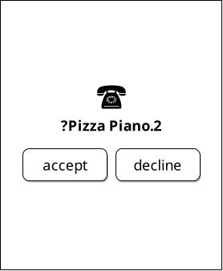
"Pizza Piano" is the proposed name, but Ben has already had contact with one of the other Pizza Piano franchise locations, and so the system distinctively marks this one as entry 2. Ben's petname system will automatically increment this number until it exceeds 9, at which case any new encounters with a proposed name of "Pizza Piano" will simply render as "Pizza Piano…"
Ben answers the call; the pizza parlor employee merely wanted to let Ben know that they were all out of olives and wanted to know if another ingredient would be acceptable. Even though Ben is trusting that caller ID is correct, he can't imagine any reason why someone would be trying to phish him to authorize a topping change, so he suggests changing from olives to mushrooms. Now all that's left for Ben to do is pick up the pizzas!

Web browser integration
While smartphone contact lists already have much in common with petname systems, web browsers require more care. But if we pay attention to what the boundaries and usage behavior of modern browsers are, a petnames system can be built which matches user expectations.
As Eric Lawrence explains, in web browsers, the browser itself typically has control over the top of the window. However, below the address bar, the webpage can display whatever it wants, causing Lawrence to call this demarcation the "Line of Death."
Even the supposedly safe area, above the Line of Death, is in danger – HTML5's Fullscreen API, for example, allows the webpage to control the entire screen area. Moreover, mobile web browsers have dispensed with the idea of a trusted header entirely.
However, web browers do get some things right. For instance, they proposed the idea that the address bar should be a trusted path. Furthermore, a web page, when visited over a secure connection, is able to present a link that does express where the web page would like you to go. And usefully browsers already provide something that is very much like petnames: bookmarks, which allow users to map a locally human meaningful name to a global identifier.
Unfortunately browsers also have different design decisions which can make providing a secure environment difficult. While it is good that the web page can direct the user successfully to another page of the original page's choosing, it is possible to "bait and switch" users into believing they are going to one web page when in fact they are being sent to another. For example, on desktop browsers if a user hovers over a link the bottom bar of a browser can indicate to a user where they will probably go. Unfortunately this is not guaranteed to be the actual place the user will be sent; for example, a web page can intercept the click in javascript and direct the user somewhere else.
To see how petnames (if correctly implemented) can help, we will analyze a specific scenario, in which a website (paypa1.com) attempts to pass itself off as paypal.com, hoping to capitalize on the similarity of appearance in the names.
Previous implementations of petnames in the browser have used a separate bar adjacent to the address bar to display the petname, such as in Tyler Close's 2005 paper. This general idea of bookmarks as petnames, as well as how they might be integrated within a browser, was borrowed from the (now defunct) Firefox extension Petname Tool which illustrated these ideas clearly.
It would be possible to implement edge names within a browser as well. If the user does not have a local petname, an edge name provided by a petname could be shown.
DNS could be imported as a kind of special purpose naming hub, retaining exiting DNS behavior. Thus, dns ⇒ paypal.com could still be provided, providing a path forward for synthesizing current address bar features along a petname system enabled address bar.
New registries with upgraded security approaches could also be added. For instance, a registry-oriented naming hub could have a strict policy of allocating all "nearby" names as a package whenever a domain name is sold, so that scammers cannot claim a lookalike name later. For instance, "DomainSpace ⇒ paypa1.com" automatically redirects to "DomainSpace ⇒ paypal.com" because paypa1 was close enough to paypal it was sold as part of the same package.

Conclusion
The most popular contemporary naming systems on the internet today are not only centralized but also vulnerable to phishing attacks. Naming systems which are secure while being globally unique and decentralized are available (such as DIDs, tor onion service addresses, et cetera) are structurally unable to be usefully human meaningful on their own.
Thankfully, there is an alternative that people can use. We have demonstrated that a personalized system composed of petnames, edge names, and proposed names (both self-proposed and otherwise) can be layered on top of impenetrable unique decentralized identifiers to provide local human meaningful mappings which are understandable and intuitive to workflows of ordinary users: a PetName system.

The pattern of using a path separator for edge names comes from SPKI/SDSI. We considered using various separators including forward slashes, the english possessive "'s", and various others, but settled on a unicode arrow to give the impression that path separators are implementation specific and that delimiters may not even be typed in by hand.
Phone numbers are one example of not-particularly-human-memorable identifiers, and since contact list applications so frequently deal with them, we've stuck with that example. Of course there's no reason a contact list couldn't deal with DIDs or other URIs or tor .onion addresses or really any such global identifiers.
It is important to deliver a reasonable sorting order to the names presented. In general, petnames should always be presented first. Following petnames should be one-level-deep edge names. What entities should be prioritized to provide edge names? This might depend on the user or application, but it would be reasonable that trust might vary here, with well known naming hubs and trusted (which may mean frequently interacted with) other entities.
One detail we've glossed over is how edge names are shared in the first place. There are many routes to providing edge names, from occasionally sharing a certificate with an entire list of edge names with all followers to querying an endpoint from a particular entity on demand. Implementations of petname systems may vary in their implementation here.
Of course a contacts system may have a composite of values for a particular entity, such as email alongside a phone number (or numbers). This is possible in a petnames system, as long as such mappings remain bidirectional, but we have left out such details from our example scenario to keep it simple.
Note that we did not suggest that Dr. Nym typed in the phone number. Typing in identifiers is problematic enough with phone numbers, and far more dangerous with larger cryptographically secure names.
This general idea of bookmarks as petnames, as well as how they might be integrated within a browser, was borrowed from the (now defunct) Firefox extension Petname Tool which illustrated these ideas clearly.
For more information on "nearby" names (also called "confusables") see Unicode Utilities: Confusables.

